EXNO: 1 Implement program for Time series data cleaning loading ,handling and

Date:23/01/25 Preprocessing Techniques

Aim:

Implement a python program for time series data cleaning handling preprocessing of silver price dataset

Procedure and code:

import pandas as pd

import numpy as np

import matplotlib.pyplot as plt

import seaborn as sns

data=pd.read_csv("/content/LBMA-SILVER.csv")

data.head()

data.plot

import pandas as pd

import matplotlib.pyplot as plt

# Sample data

data = {

"Date": ["2022-04-21", "2022-04-20", "2022-04-19", "2022-04-14", "2022-04-13"],

"High": [24.645, 25.200, 25.915, 25.655, 25.640],

"Low": [18.87, 19.30, 19.89, 19.54, 19.72],

"Close": [22.61, 23.21, 24.01, 23.53, 23.68],

}

# Convert to DataFrame

df = pd.DataFrame(data)

# Convert the 'Date' column to datetime

df['Date'] = pd.to_datetime(df['Date'])

# Set the 'Date' column as the index

df = df.set_index('Date')

# Plot the 'Close' prices

plt.figure(figsize=(10, 6))

plt.plot(df.index, df['Close'], label='Close Prices', marker='o', color='blue')

plt.title('Time Series Plot of Close Prices')

plt.xlabel('Date')

plt.ylabel('Close Price')

plt.grid()

plt.legend()

plt.show()

|  |  |  |  |  |
| --- | --- | --- | --- | --- |
|  | DATE | USD | GBP | EURO |
| 0 | 2022-04-21 | 24.645 | 18.87 | 22.61 |
| 1 | 2022-04-20 | 25.200 | 19.30 | 23.21 |
| 2 | 2022-04-19 | 25.915 | 19.89 | 24.01 |
| 3 | 2022-04-14 | 25.655 | 19.54 | 23.53 |
| 4 | 2022-04-13 | 25.640 | 19.72 | 23.68 |

OUTPUT:

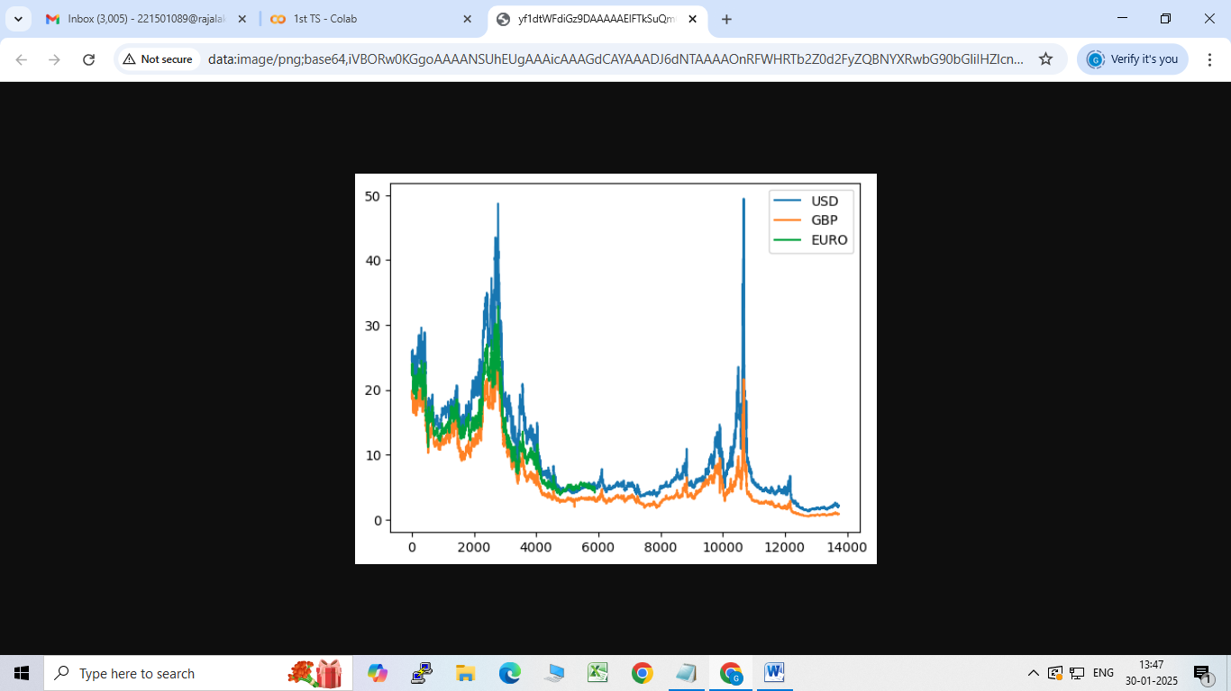

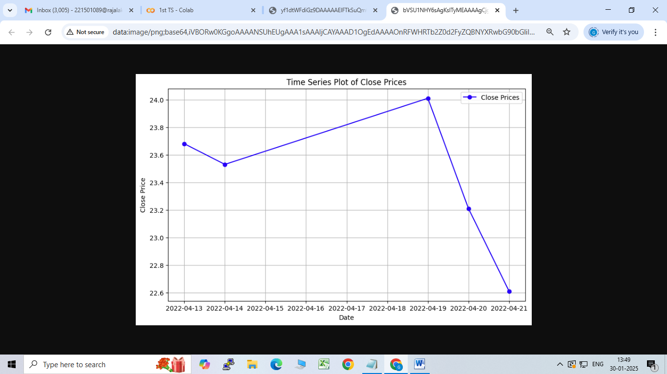

Result :

Thus the program has been executed successfully